Tab 1



Mtel (Thailand) Co., Ltd.

For

T.C.C. Technology Co., Ltd.

One Bangkok Mobile Application
Migration Campaign
Technical Design Document
To
T.C.C. Technology Co., Ltd.

Total 14 sheets (w/h cover sheet)
 | PROJECT NAME | JOB NO. | DOCUMENT NO. | REV.
 | One Bangkok Mobile Application - Migration Campaign Technical Design Document |  |  | 01

Content table
1. Document Purpose 3
2. Project Background & Overview 4
3. Goals & Non-Goals 5
3.1. Goals 5
3.2. Non-Goals 5
4. System Architecture 6
4.1. Architectural Overview 6
4.2. Component Architecture 6
4.2.1. Controller Layer/Trigger Layer 6
4.2.2. Service Layer 6
4.2.3. External Integration Layer 7
4.2.4. Environment Configuration 7
5. Functional Design 7
5.1. Migration Campaign Flow 7
6. Data Flow 9
6.1. End-to-End Migration Campaign Flow 9
7. Example Request/Response 10
7.1. GET /campaign/{campaignId}?device_locale=1033 10
7.1.1. Request 10
7.1.2. Response (Success - 200) 10
7.1.3. Response (Error - 409) 10
7.2. POST /api/auth/server_login 11
7.2.1. Request 11
7.2.2. Response (Success - 200) 11
7.3. POST /campaign/{campaignId}/redeem 11
7.3.1. Request 11
7.3.2. Response (Success - 200) 11
7.3.3. Response (Error - 409) 13
7.4. PATCH /connectx/api/object/customers 13
7.4.1. Request 13
7.4.2. Response (Success - 200) 13
7.5. Error Scenarios 14

One Bangkok Mobile Application - Migration Campaign
To
T.C.C. Technology Co., Ltd.
This document serves as the official Technical Design Document (TDD) for the implementation of the Migration Campaign feature within the One Bangkok Application, integrated through the Single Sign-On (SSO) platform and BZB ecosystem. The initiative defines the automated campaign eligibility check and redemption flow triggered upon a user's first login or account merge via the One Bangkok Application.
The primary objective is to ensure that eligible migrated users automatically receive their campaign benefit upon joining the platform, without requiring any manual action. The feature integrates SSO, BZB campaign APIs, and Connect X to deliver a seamless and reliable migration reward experience.
This document describes the proposed architecture, functional design, API interactions, and environment configuration to align all stakeholders at T.C.C. Technology Co., Ltd. and to support the successful implementation and deployment of the solution.

Document Purpose
The purpose of this Technical Design Document (TDD) is to define the technical architecture, system interactions, API contracts, and implementation approach for the Migration Campaign feature in the One Bangkok Application.
This document provides detailed guidance on how the campaign eligibility check and redemption process will be designed and implemented using SSO as the orchestration layer, BZB as the campaign and authentication provider, and Connect X as the CRM update target. It serves as a reference for development, quality assurance, and operations teams to ensure consistent understanding and execution.
Additionally, this TDD establishes design principles, technical assumptions, API specifications, and environment dependencies, enabling stakeholders to assess feasibility, identify risks, and align on implementation standards prior to development.
The document is intended to support the successful delivery of a secure, reliable, and maintainable solution that ensures migrated users receive their entitled campaign benefits upon first login or account merge.

Project Background & Overview
When a user performs their first login or merges their account via the One Bangkok Application, the system is required to automatically check whether that user is eligible for a predefined migration campaign and, if eligible, redeem the campaign on their behalf.
Currently, this eligibility check and redemption process is triggered by SSO upon successful account creation or merge. The flow involves multiple downstream integrations: a campaign eligibility check against BZB, a server-side authentication to obtain a BZB server token, a campaign redemption call, and a subsequent update to Connect X to reflect the user's redemption status and marketing preferences.
The feature is controlled by a feature flag (CHECK_AND_REDEEM_CAMPAIGN_IF_ELIGIBLE) and a campaign identifier (CAMPAIGN_ID) configured in the environment, allowing the flow to be enabled or disabled without code changes.
At a high level, the solution consists of:
- SSO orchestrating the eligibility check and redemption sequence post account creation or merge
- BZB providing campaign data, server authentication, and redemption processing
- Connect X receiving a CRM update upon successful redemption, with retry logic to handle transient failures

Goals & Non-Goals

Goals
The goals of this technical design are to:
- Automatically trigger a campaign eligibility check upon user first login or account merge via the One Bangkok Application
- Integrate with BZB campaign APIs to validate eligibility based on campaign quantity, expiry date, and user registration date
- Perform server-side authentication with BZB to obtain a secure server token for campaign redemption
- Redeem the campaign on behalf of eligible users without requiring any user action
- Update Connect X with the user's redemption status and marketing opt-out preference upon successful redemption
- Support retry logic (up to 3 attempts with backoff) for Connect X update failures
- Enable feature flag control to activate or deactivate the campaign flow without deployment

Non-Goals
The following items are explicitly out of scope for this design:
- User-facing UI for campaign redemption — the entire flow is backend-driven and invisible to the user
- Management or creation of campaigns within BZB — campaigns are pre-configured by the BZB/Retail team
- Changes to existing BZB campaign structures, reward logic, or tier assignment rules
- Handling of campaign types other than the designated Migration Campaign
- Implementation of admin tooling or dashboards for monitoring campaign redemption status
- Modifications to Connect X data models beyond the fields specified in this document

System Architecture

Architectural Overview
The Migration Campaign feature is implemented as an automated post-registration/merge process within the SSO service. It follows a sequential integration pattern:
- SSO — acts as the orchestration layer, triggering the campaign flow after successful account creation or merge
- BZB Campaign API — provides campaign details and validates eligibility conditions
- BZB Auth API — issues a server-side token used for the redemption call
- BZB Redemption API — processes the campaign redemption on behalf of the user
- Connect X API — receives a CRM update after successful redemption, with retry on failure
The feature is gated by environment-level configuration, ensuring no impact when the feature flag is disabled.

Component Architecture

Controller Layer/Trigger Layer
- Trigger point: Post account creation or account merge within SSO
- Method called: checkAndRedeemCampaignIfEligible()
- Responsibilities:
  - Read CAMPAIGN_ID and CHECK_AND_REDEEM_CAMPAIGN_IF_ELIGIBLE from environment
  - Gate execution: proceed only if both campaignId exists and featureFlag = true
  - Pass control to the campaign eligibility and redemption service

Service Layer
- Method: checkAndRedeemCampaignIfEligible()
- Responsibilities:
  - Call GET /campaign/{campaignId} to retrieve campaign details from BZB
  - Evaluate eligibility conditions:
    - qty > 0 — campaign has remaining quota
    - now < ExpireDate — campaign has not expired
    - register_date < StartDate — user registered before the campaign start date
  - If all conditions are met:
    - Call POST /api/auth/server_login with uuid = BKL_ID to obtain a BZB server token
    - Call POST /campaign/{campaignId}/redeem with the server token to redeem the campaign
    - Upon successful redemption (isRedeemed = true and accountId + campaignCode confirmed):
      - Prepare MigrationCampaignBody with cx_profileId and notificationMarketingOptOut
      - Call PATCH /connectx/api/object/customers?externalId=cx_profileId
      - If Connect X update fails → apply retryWithBackoff, maximum 3 retries

External Integration Layer
Integration | Endpoint | Purpose
BZB Campaign API | GET /campaign/{campaignId}?device_locale=1033 | Retrieve campaign details and eligibility data
BZB Auth API | POST /api/auth/server_login | Obtain server-side JWT for redemption
BZB Redemption API | POST /campaign/{campaignId}/redeem | Redeem campaign on behalf of user
Connect X API | PATCH /connectx/api/object/customers?externalId=cx_profileId | Update CRM with redemption status and marketing preference

Environment Configuration
Variable | Example Value | Purpose
CAMPAIGN_ID | UAT: 1517026  Prod: 8767309 | Campaign identifier for the migration campaign
CHECK_AND_REDEEM_CAMPAIGN_IF_ELIGIBLE | true | Feature flag to enable or disable the campaign flow
BZB_API_BKL | https://apibkl.buzzebees-uat.com | BZB API base URL for campaign and redemption calls
BZB_AUTH_API_URL | https://apigateway.buzzebees-uat.com | BZB API Gateway base URL for server login

Functional Design

Migration Campaign Flow
    - Narrative: Upon a user's first login or account merge via the One Bangkok Application, SSO automatically invokes checkAndRedeemCampaignIfEligible(). This function checks the configured migration campaign against BZB eligibility rules and, if the user qualifies, redeems the campaign silently on their behalf and updates their Connect X profile accordingly.
The entire flow is asynchronous and non-blocking to the user's login or merge experience.

    - Eligibility Check Logic: After retrieving campaign details from BZB via GET /campaign/{campaignId}, the following conditions are evaluated:
Condition | Rule | Description
Campaign quota | qty > 0 | Campaign must have remaining redemptions available
Campaign validit | now < ExpireDate | Current timestamp must be before the campaign expiry
User registration timing | register_date < StartDate | User must have registered before the campaign start date
All three conditions must be true for the user to be considered eligible. If any condition fails, the flow terminates without error and no redemption is attempted.

    - Campaign Redemption: If the user is eligible
      - Call POST /api/auth/server_login with uuid = BKL_ID to obtain a BZB server token (JWT)
      - Use the server token to call POST /campaign/{campaignId}/redeem with the appropriate headers (Authorization: Bearer {serverToken}, App-Id)
      - Confirm redemption success: isRedeemed = true and accountId + campaignCode are present in the response
    - Connect X Update: Upon confirmed redemption
      - Prepare the request body with cx_profileId and notificationMarketingOptOut
      - Call PATCH /connectx/api/object/customers?externalId=cx_profileId
      - On success (200): flow completes
      - On failure: apply retryWithBackoff, maximum 3 retries
      - If all retries are exhausted: log the failure and exit gracefully — do not roll back the redemption

Data Flow

End-to-End Migration Campaign Flow

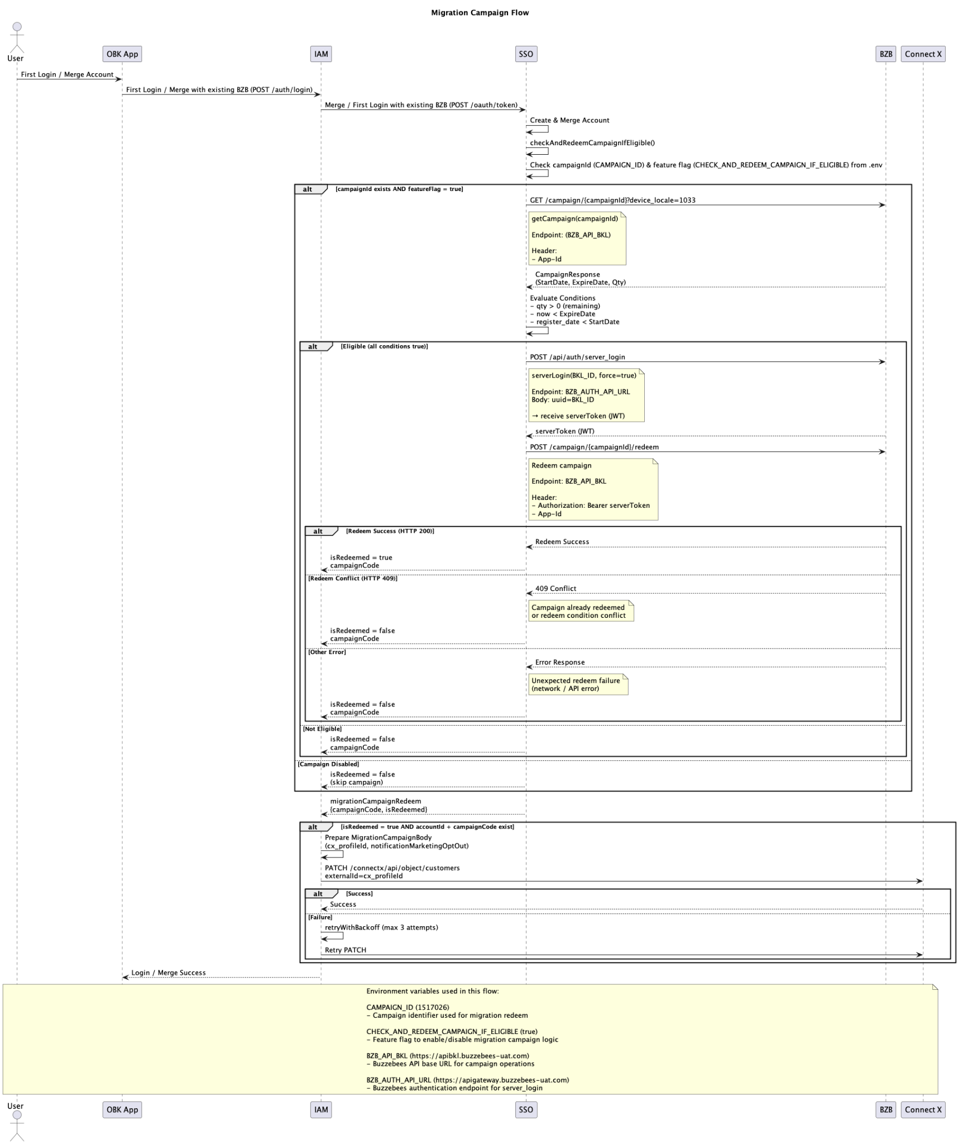

Example Request/Response

GET /campaign/{campaignId}?device_locale=1033

Request
GET {BZB_API_BKL}/campaign/{campaignId}?device_locale=1033
Headers:
App-Id: XXXX

Response (Success - 200)
{
"ID": 1518888,
"StartDate": 1773792000,
"ExpireDate": 1777593599,
"Qty": 1.0,
"StatusID": 4,
"IsConditionPass": false,
"ConditionAlertId": 1
}

Response (Error - 409)
{
"requestId": "dfec266e-6f5c-4f3c-b16e-0840a59903d9",
"error": {
"id": 1905,
"message": "Session Expired. Please login again to continue.",
"code": 409,
"type": "buzzebees"
}
}
```

**Error Scenarios**

| Error | Status | Cause |
|---|---|---|
| Session expired | 409 | BZB session invalid or expired |
| Campaign not found | 404 | Invalid campaignId |
| Other errors | TBC | To be confirmed with BZB team |

POST /api/auth/server_login

Request
Header:

{
“App-Id”:”XXXX”,
“Ocp-Apim-Subscription-Key”:”XXX”,
“api-version”:”XX”,
“country-prefix”:”th”
}

Body:

Formdata {uuid: “BKL_XXX”}

Response (Success - 200)
{
"token": "<server_token>",
"userId": "BKL_1773322167793",
"appId": "3349033408732050",
"uuid": "BKL_1773322167793",
"jwt": "<JWT>",
"canRedeem": true,
"channel": "server"
}

POST /campaign/{campaignId}/redeem

Request
Header:

{
“Authorization”: `Bearer ${service_login.token}`,
“App-Id”: “XXXX”
}

Response (Success - 200)
{
"CampaignId": 1517026,
"ItemNumber": 47,
"Serial": "65410769",
"AgencyId": 146547,
"AgencyName": "bkl_onebangkok",
"CatId": 9513271,
"Name": "Interval PreCode_TTB_2,500 Get 100 [Convert to E-Voucher] (Max1/day - limit 10)",
"NextRedeemDate": 1774915200,
"CurrentDate": 1774863467,
"RedeemCount": 1,
"UseCount": 0,
"Qty": 53.0,
"IsConditionPass": false,
"ConditionAlert": "You have reached the redeeming limit",
"IsNotAutoUse": true,
"PointType": "use",
"InterfaceDisplay": null,
"RedeemKey": "1517026_47",
"PricePerUnit": 0.00,
"WalletCard": null,
"NextRedeemDatePerCard": null,
"RedeemCountPerCard": 1,
"UseCountPerCard": 0,
"CategoryDetail": "Convert to E-Voucher (Step1)",
"MasterCampaignName": null,
"RedeemDate": 1774863467,
"CampaignName": "Interval PreCode_TTB_2,500 Get 100 [Convert to E-Voucher] (Max1/day - limit 10)",
"PointPerUnit": 0.0,
"ConvertPoints": null,
"ConvertPrice": null,
"FullImageUrl": "https://cdn.buzzebees-uat.com/th/campaigns/1517026?time=20260326102119",
"Type": 1,
"IsUsed": false,
"ExpireIn": null,
"PrivilegeMessage": "1513716",
"PrivilegeMessageEN": "1513716",
"PrivilegeMessageFormat": "text",
"buzzebees": {
"traces": [
{
"Id": "Redeem",
"Current": 0,
"Change": 1,
"Points": 0,
"ObjectId": null,
"ValueResetReason": "period",
"UserDescription": "Redeem Activities",
"UserLevel": 0,
"CustomInfo": null,
"LineMessageSetting": null,
"PointUnit": null,
"PointSuccess": true
}
]
}
}

Response (Error - 409)
{
"requestId": "0dd1005b-e336-4440-8462-e44458b7bc4d",
"error": {
"id": 2,
"message": "You have reached the redeeming limit",
"code": 409,
"type": "buzzebees"
}
}

PATCH /connectx/api/object/customers

Request
Header:
{
“Authorization”:”Bearer xxx”
}

Body
{
“cx_profileId”:”xxxx”,
“notificationMarketingOptOut”:true
}

Response (Success - 200)
{
"id": "response_id"
}

Error Scenarios
Error | Status | Cause | Cause
Update failure | 409 | Connect X service error | Retry with backoff, max 3 attempts
All retries exhausted |  | Persistent Connect X failure | Log failure, exit gracefully
Example Kibana: https://kibana.tccproptech.com/app/discover#/?_g=(filters:!(),refreshInterval:(pause:!t,value:60000),time:(from:now-30d%2Fd,to:now))&_a=(columns:!(log,kubernetes.container_name),dataSource:(dataViewId:aae2df20-57d2-4ba6-bb60-305aa4732220,type:dataView),filters:!(),grid:(columns:(timestamp:(width:212))),hideChart:!t,interval:auto,query:(language:kuery,query:%27%22checkAndRedeemCampaignIfEligible%22%20or%20%22migrationCampaign%22%27),rowsPerPage:500,sort:!(!(timestamp,asc)))

